**Pilot CO2 uptake rewetting measures Hunzedal**

Weier Liu, Merijn Slagter, Christian Fritz

# **1 Introduction**

Rewetting measures have been taken or are planned in different areas in 'Het Hunzedal'. Rewetting former agriculture lands may reduce GHG emissions.

In this project, we quantify the emission reduction that:

* already took place in rewetted areas in the past
* is projected to take place in the future (till 2050)

The focus is on three areas:

* Tusschenwater (currently rewetted)
* LOFAR (rewetted in late 1990's)
* Zoersche Landen (rewetted in late 2000's)

# **2 Methods**

The following two scenarios are evaluated for the next 30 years for the potential GHG emissions:

* Business as Usual (BAU):

Continuing agricultural land use indicated by current land use map.

* Rewetting:

Higher ground water level and changed vegetation cover indicated by predicted vegetation map and water level data.

For each of the scenarios, 3 approaches are implemented for GHG emissions calculation.

1. Direct use of emission factors per land use/ vegetation types:

The emission factors for BAU scenario is IPCC default values of CO2 emission for different land use types; emission factors for Rewetting scenario is the CO2 emission potential for different vegetation cover from literature.

1. Calculate emissions as a function of ground water level and peat thickness (using available or predicted water level maps):

We use 0.5 ton CO2 ha-1 yr-1 as the parameter for each centimeter of dry peat layer to calculate CO2 emissions based on water level and peat thickness maps. Predicted water level map for the area is used.

1. Calculate emissions as a function of ground water level and peat thickness (deriving water level maps from land use/ vegetation types):

We use the same function as approach 2) for the calculation. The water level data is converted from vegetation map based on vegetation-water level relations from literature.

A screenshot of a cell phone

Description generated with very high confidence

# **3 Intermediate Results**

We used data for Tusschenwater as an example in this report. We calculated CO2 emission for both scenarios using emission factors (approach 1), for BAU scenario, the total CO2 emission in 30 years is 105290.2 tons, and for Rewetting scenario, there is a major reduction to 13056.75 tons (Appendix A).

Results from the 3 different approaches for the Rewetting scenario (Appendix B) were also compared as in the table below:

|  |  |  |
| --- | --- | --- |
| Approaches | Mean CO2 emission rate  (ton / ha yr) | Total CO2 emission (ton / yr) |
| 1 | 8.36 | 1260.31 |
| 2 | 6.69 | 1009.01 |
| 3 | 19.65 | 2961.72 |

This is only intermediate results, based on further refinement of methods and data available we can have altered results. The tables and figures showed gives an impression of the changes.

# **4 Next steps**

* Implementation of subsidence rates of peat in the scenario analysis of Tusschenwater.
* Building GHG reduction models for Zoersche Landen and LOFAR.
* Update for GWP.

Before we can continue our project, we need some more data (see attachment for our data question)

# **Appendix A**

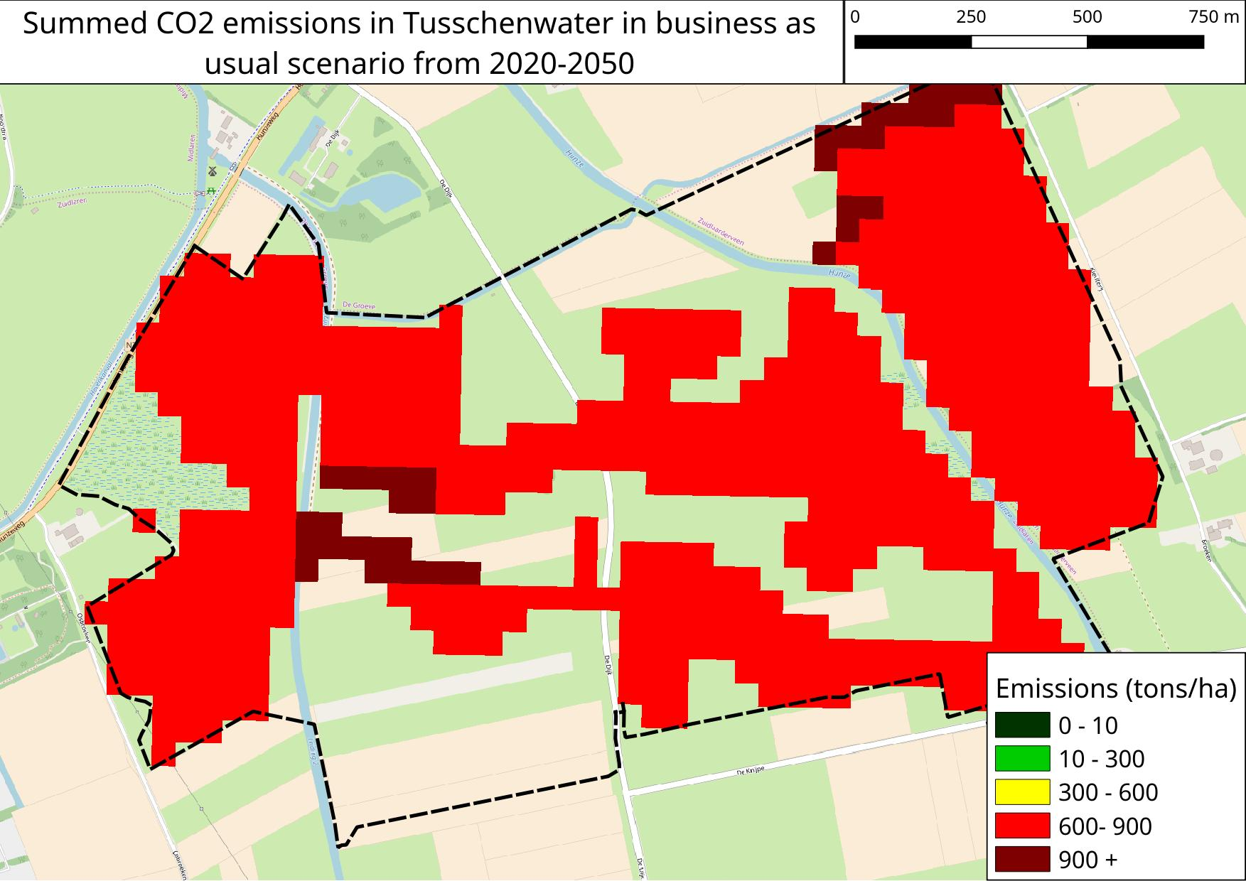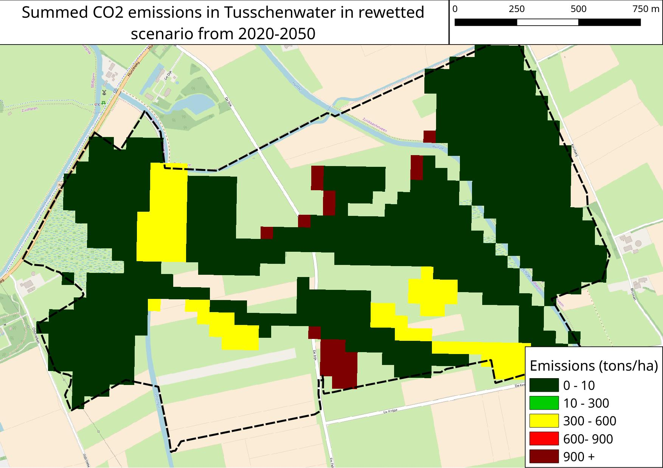

# **Appendix B**

A picture containing text, map

Description generated with very high confidenceA close up of a map

Description generated with high confidenceA close up of a map

Description generated with high confidence